A Small Tour of the Metropolitan Museum of Art

|  |
| --- |
|  |

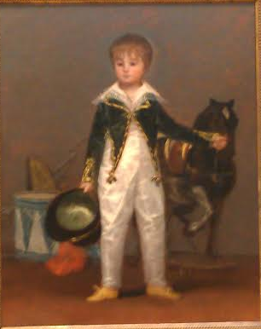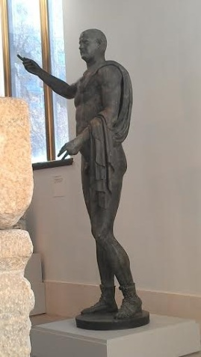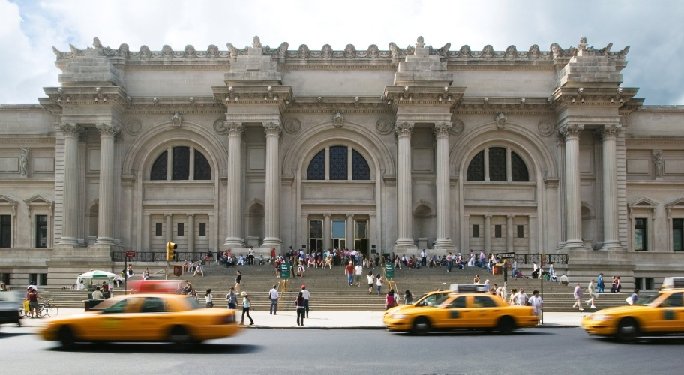

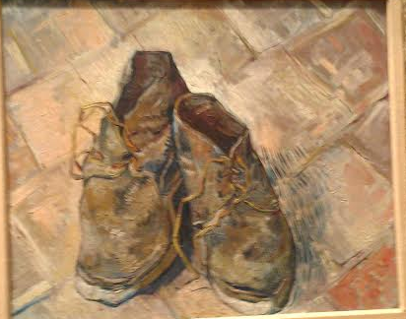

*Pepito* is an oil on canvas painting done by Francisco de Goya y Lucientes in 1810. Pepito's full name is José Costa y Bonells. When someone looks at the overall painting, they may describe the color as dull. The horse, drum, and gun seemingly blend and blur into the dark background. It is what does not stand out that truly captures attention. The boy's green vest and one-piece pants and undershirt combination reminiscent of a military uniform seem to be brighter and slightly more vibrant than the background. The very novelty of the one-piece to the eyes of a modern viewer catches the eye. If one looks closer, splotches of skin can be seen through the thin one-piece. Around Pepito is his toy horse, drums, and gun. These objects seem childlike to start with, but his face speaks volumes. The way the boy looks with his eyes and the position of his eyebrows show a deep longing. This face agrees with one of a soldier, which continues the militaristic theme of the artwork. The innocence of this baby-faced boy clashes with the -militaristic theme.

**

* Shoes* is an oil on canvas painting created by the Dutch artist Vincent Van Gogh in 1888. He painted several still lifes of shoes or boots during his time in Paris. What sets this apart from the still lifes is that these shoes are painted onto the red-tile floor of the Yellow House. The brushstrokes in this piece are apparent in the whole piece, but the tiles especially. The shoes are painted with finer detail. The entire painting itself looks deformed. The tiles are not straight and the shoes and shoelaces look as if someone took the shoes off in a hurry. The collar of the left shoe (the viewer's left) looks like it was squeezed. The collar of the right shoe is lopsided. The shoelaces are the highlight of this piece. The fact that the shoelaces are bent at stiff angles as opposed to curves and all shoelaces are leaning left seemed odd. Another thing that seemed peculiar was the shadow on the right. Instead of being a near solid dark shape, it is a series of dashed strokes. Overall, the painting's earthy tones leans towards a rustic feel. This combined with the aged and used appearance of the shoes makes this a still life of an old working man's shoes.

This is a bronze statue of the Roman emperor Trebonianus Gallus made in 251–253 A.D drawn from the conveniently placed far right bench. It is about 95 in. or 241.3 centimeters high. This statue is unique in numerous ways. One way is that in the room that hosts the statue, there is only white marble artwork displayed, but among the white artworks rests a dark bronze statue. The emperor also appears to have been holding something or even showcasing a weapon. In addition, Roman statues tended to have a body that was ideal, lean and muscular. His arms and legs are definitely muscular to some extent, but his chest is more stomach than abs. Even without muscular definition, Trebonianus Gallus maintains   
 a royal and fierce pose.

http://hydra-media.cursecdn.com/terraria.gamepedia.com/a/a3/Cyborg.png?version=14a25357c184afee215fca33fa7d8eb4

Ah, first, a brief summary of the history of the museum. It was founded in 1870. The Metropolitan's paintings collection also began in the same year, when a total of 174 paintings across three private European collections came to the museum. It wasn't until 1880 that it was moved to its current site at Central Park. Various additions to the building were added as early as 1888. The present entrance structure on Fifth avenue was completed in 1926.



I present to you some of the experts at this museum. Rondra, an expert on ancient near eastern art, Tobias, an expert on 19th and 20th century European art, and Bob, an expert on all the sculptures in the museum.

http://hydra-media.cursecdn.com/terraria.gamepedia.com/a/a3/Cyborg.png?version=14a25357c184afee215fca33fa7d8eb4



There's no way you can see all aspects of a statue from one drawing. Here are some gesture drawings from conveniently placed benches around the museum. The drawings are drawn from as follows: the far right bench, the front bench, the slightly left bench, and the far left bench. The security guards won't let you hang around the back of the statue apparently.

http://hydra-media.cursecdn.com/terraria.gamepedia.com/a/a3/Cyborg.png?version=14a25357c184afee215fca33fa7d8eb4

And this concludes this small sample tour of the Metropolitan Museum of Art.





Just to make sure credit is due where it needs to be, we are actually sprites from a game called Terraria.

These aren't even our art critiques.



http://hydra-media.cursecdn.com/terraria.gamepedia.com/a/a3/Cyborg.png?version=14a25357c184afee215fca33fa7d8eb4

Nor are these drawings of the artworks done by us.

They are done by the same person controlling us, Jonathan Quang



Bibliography

1. "A Brief History of the Museum." *A Brief History of the Museum*. Metropolitan Museum of Art, n.d. Web. 02 Jan. 2015. <http://www.metmuseum.org/about-the-museum/press-room/general-information/2005/a-brief-history-of-the-museum>.

Peña, Elizabeth, and Marlin Lum. "4-Day RTI Training at the Metropolitan Museum of Art." *Cultural Heritage Imaging*. N.p., 05 Jan. 2011. Web. 02 Jan. 2015. <https://culturalheritageimaging.wordpress.com/2011/01/05/4-day-rti-training-at-the-metropolitan-museum-of-art/>.

*Terraria*. Computer software. *Terraria*. Vers. 1.2.4.1. Re-Logic, 16 May 2011. Web. 2 Jan. 2015. <http://terraria.org/>.

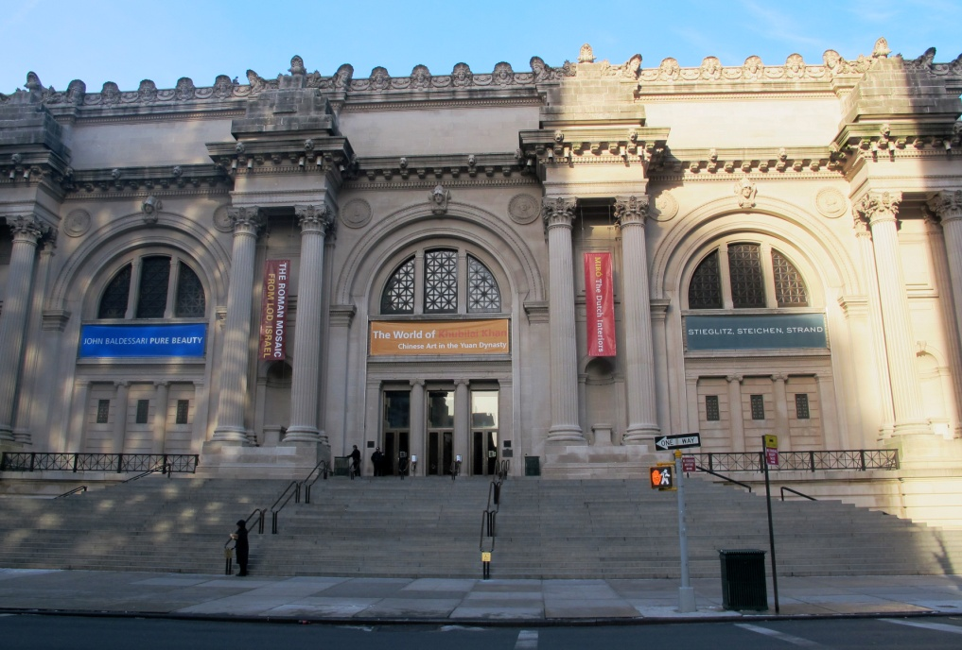

You can find the museum at 1000 5th Avenue, New York, NY 10028. Give the museum a call at (212) 535-7710. Don't tell them I sent you.

Hello, I am Robert and I will be your tour guide through a small sample of the Metropolitan Museum of Art